**Experiment 1.1**

**Student Name:** Gaurav Kumar**UID:** 22MCC20177

**Branch:**MCA CC & Devops**Section/Group:** 22MCD-1-A Group

**Semester:**2**Date of Performance:** 15-02-2023

**Subject Name:** Cloud Computing Lab**Subject Code:** 22CAP-687

**Aim/Overview of the practical:**

1. Create a Google Form that will take the Feedback of 6 subject teachers.
2. Create a Google Sheet & enter the 5 subject marks for 10 students. Calculate the sum of marks, then average, and find max & min marks of each subject.

**Task to be done**

To create a Google form with the linear scale marking for feedback. And to create a Google Sheets that will perform some mathematical calculations by using the respective formulas of sum, average, max, min, etc.

**Code/Steps for the Practical :**

1. **Google Form:**

**Step 1)** Go to Gmail home page and click on the Google Apps menu on the top right corner

**Step 2)** Scroll down & search for the Forms. Click on it. You’ll land on the Google Forms Home Page/Landing Page.

**Step 3)** Now, click on “Blank (Start a new form)”. Set the Heading & Title of the form.

**Step 4)** Then, go ahead and enter some questions. We can create MCQs, Short/Long answers, or a Linear Scale for feedback.

**Step 5)** Similarly, enter feedback questions for 6 subjects. We may add different sections for different subjects by clicking on the “Sections” option in the menu of the form.

**Step 6)** Finally, after entering all the questions, we can preview the form by clicking on the eye button on the top right corner of the form page OR we can share it by clicking on the Send Button via URL, or E-Mail. 2

1. **Google Sheets:**

**Step 1)** Go to Gmail home page and click on the Google Apps menu on the top right corner

**Step 2)** Scroll down & search for the Sheets. Click on it. You’ll land on the Google Sheets Home Page/Landing Page.

**Step 3)** Now, click on “Blank (Start a new Spreadsheet)”. Set the Heading & Title of the form.

**Step 4)** Then, go ahead and enter the column names and fill in the data of students such as Name, UID, subject marks, total marks, average marks, max marks, and min marks.

**Step 5)** Carefully calculate these rows with the help of formulas like: -

**For Sum: - “=SUM(C2:C11)”**

**For Max: - “=MAX(C2:C11)”**

**For Average: - “=AVERAGE(C2:C11)”**

**Output:**

1. **Google Form:**

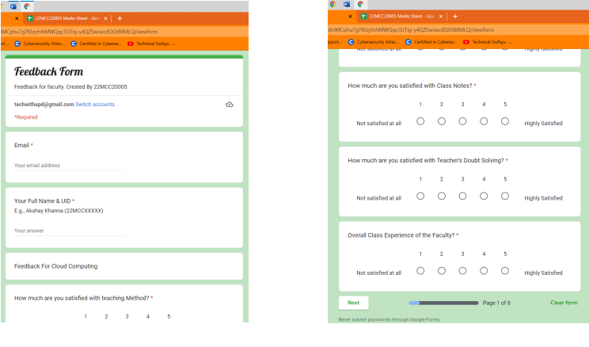

1. **Google Sheet:**

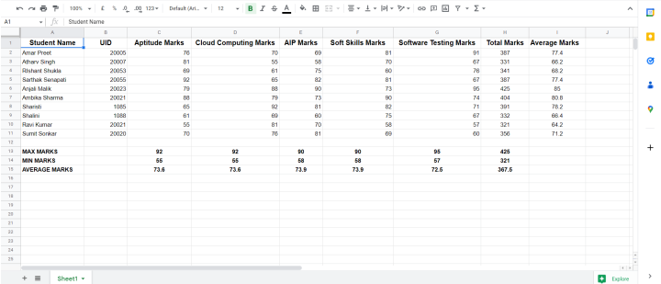

**Learning Outcomes (What I have learned)**

* I Learned to: -
  + - * Create a Google Form with various fields including a different section.
      * Create a Google Sheet & implement the mathematical calculations using the arithmetic formulas of the spreadsheet.

**Evaluation Grid:**

|  |  |  |  |
| --- | --- | --- | --- |
| Sr. No. | Parameters | Marks Obtained | Maximum Marks |
| 1. | Demonstration and Performance  (Quiz) |  | 22 |
| 2. | Worksheet |  | 8 |